**Test Report**

**WebstaurantStore – Empty Cart**

May 2020

**Resources**

|  |  |
| --- | --- |
| **Role** | **Name** |
| Test Manager | Jeff Robert |
| Tester | Phuong Nguyen |

**Revision Sheet**

|  |  |  |
| --- | --- | --- |
| **Release No.** | **Date** | **Revision Description** |
| Rev. 0 | 5/22/2020 | Initialize project |
| Rev. 1 | 5/25/2020 | Created page objects structure |
| Rev. 2 | 5/26/2020 | Completed test flows and validation |

Table of Contents

1.GENERAL INFORMATION 2

1.1 Purpose 2

1.2 Testcase Steps 2

1.3 Testing Scope 2

1.4 Test Metrics 2

1.5 Test Environment & Tools 3

2. TEST EXECUTION 3

2.1 Simple Result 3

2.2 Detail Result 4

# 1.GENERAL INFORMATION

## 1.1 Purpose

This document explains the various activities performed as part of the Testing of the ‘WebstaurantStore’ application with test flow: search product > add in cart > empty cart.

## 1.2 Testcase Steps

|  |
| --- |
| 1. Go to <https://www.webstaurantstore.com/> 2. Search for 'stainless work table'. 3. Check the search result ensuring every product item has the word 'Table' its title. 4. Add the last of found items to Cart. 5. Empty Cart. |

## 1.3 Testing Scope

|  |  |
| --- | --- |
| In Scope | Functional Testing:   * Search product * Verify the search function result * Add item into the Cart * Empty Cart   Execution Option:   * Simple report * Detail report |
| Out of Scope | * Do not handle to allow user to change number of products in the “Cart Page” * Do not handle search wrong keyword > lead to not-found page yet |
| Verification | 1. Search function > Verify search result 2. Add last found product into Cart > Verify last product is displayed on the Cart page after adding 3. Empty cart > Verify the message your cart is empty should be displayed |

## 1.4 Test Metrics

|  |  |
| --- | --- |
| Test cases executed | Test case Result |
| 1 | |  |  | | --- | --- | | Action | Result | | Search ‘stainless work table’ | 9 pages of result is returned  ? products found | | Verify every product contains ‘Table’ in title | FAIL  5 products do not match | | Add the last of found items into Cart | added | | Verify product was added into the Cart | PASS | | Empty Cart | empty | | Verify empty | PASS | |

## 1.5 Test Environment & Tools

|  |  |
| --- | --- |
| Application url | <https://www.webstaurantstore.com/> |
| Git link of project | <https://github.com/ntpdlp/WebstaurantStoreTest> |
| Java | JDK 1.8 |
| Selenium-Java | 3.14.0 |
| Selenium-chrome-driver | 3.14.0 |
| JUnit | 4.12 |
| Chromedriver | 83.0 |
|  |  |

# 2. TEST EXECUTION

## 2.1 Simple Test Report

|  |
| --- |
| Testcases/AddToCart.java  testReportMode = Constant.*SIMPLE_TESTCASE_REPORT*; |
| Search Result is displayed in 9 pages.  Verifying on page: 1  Verifying on page: 2  Verifying on page: 3  Verifying on page: 4  Verifying on page: 5  Verifying on page: 6  Verifying on page: 7  Verifying on page: 8  Verifying on page: 9  Last of Found Product: Advance Tabco TSS-303 30" x 36" 14 Gauge Open Base Stainless Steel Commercial Work Table  Verify every product contains 'Table': false  Verify product is added into cart successfully: true  Verify after empty cart 'Your cart is empty': true  Test Done! |

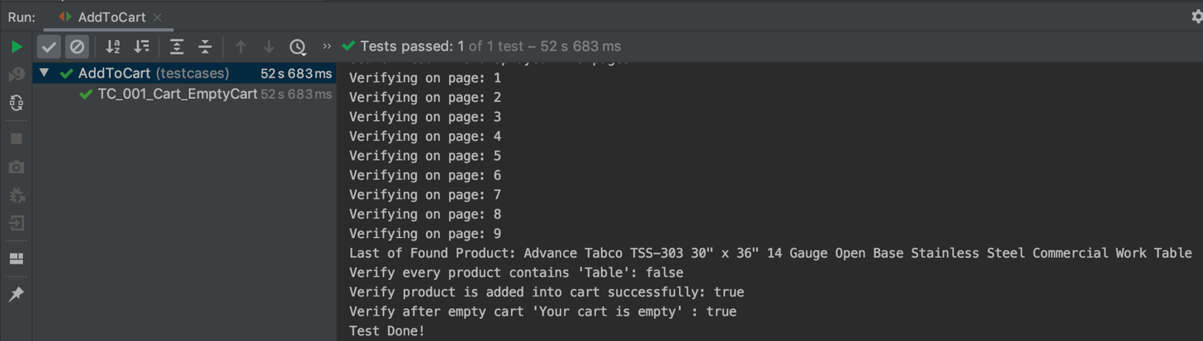

## 2.2 Detail Test Report

|  |
| --- |
| Testcases/AddToCart.java  testReportMode = Constant.*DETAIL_TESTCASE_REPORT*; |
| Search Result is displayed in 9 pages.  Verifying on page: 1  Verifying on page: 2  Verifying on page: 3  Verifying on page: 4  Verifying on page: 5  Verifying on page: 6  Verifying on page: 7  FAIL ProductId: productBox46 does not contain "Table" in its title  plus  Steelton 30" x 36" 18-Gauge Stainless Steel Equipment Stand with Undershelf and Galvanized Legs  #522SG3036  $106.99/Each  FAIL ProductId: productBox49 does not contain "Table" in its title  plus  Steelton 30" x 24" 18-Gauge Stainless Steel Equipment Stand with Undershelf and Galvanized Legs  #522SG3024  $86.99/Each  FAIL ProductId: productBox54 does not contain "Table" in its title  plus  Steelton 30" x 48" 18-Gauge Stainless Steel Equipment Stand with Undershelf and Galvanized Legs  #522SG3048  $138.49/Each  FAIL ProductId: productBox60 does not contain "Table" in its title  plus  Steelton 30" x 60" 18-Gauge Stainless Steel Equipment Stand with Undershelf and Galvanized Legs  #522SG3060  $172.99/Each  Verifying on page: 8  FAIL ProductId: productBox20 does not contain "Table" in its title  plus  Steelton 30" x 72" 18-Gauge Stainless Steel Equipment Stand with Undershelf and Galvanized Legs  #522SG3072  $196.49/Each  Verifying on page: 9  Last of Found Product: Advance Tabco TSS-303 30" x 36" 14 Gauge Open Base Stainless Steel Commercial Work Table  Verify every product contains 'Table': false  Verify product is added into cart successfully: true  Verify after empty cart 'Your cart is empty': true  Test Done! |